**South Gloucestershire Council  
Pharmaceutical Needs Assessment Supplementary Statement**

This supplementary statement has been prepared and issued by the Director of Public Health on behalf of the Health and Wellbeing Board of South Gloucestershire and forms part of the Pharmaceutical Needs Assessment. This supplementary statement is issued in accordance with Reg 6(3) of the NHS (Pharmaceutical and Local Pharmaceutical Services) Regulations 2013.

|  |  |
| --- | --- |
| Date Pharmaceutical Needs Assessment Published: | September 2022 |
| Date Supplementary Statement Published | January 2023 |
| Supplementary Statement Number: | 2 |

**Type of change**

|  |  |
| --- | --- |
| Covid-19 update |  |
| New Opening |  |
| Pharmacy Closure(s) |  |
| Temporary closure of pharmacy |  |
| Pharmacy Relocation |  |
| Change in Hours | x |
| Change in Ownership |  |
| Changes in Services |  |
| Consolidation of pharmacies |  |

**Details**

Name of Pharmacy: **Thornbury Pharmacy**

Address:  **8-10 Horseshoe Lane Thornbury BS35 2AZ**

Please note that the above named pharmacy , further to notification to change supplementary opening hours is **now closed at 18:00 instead of 18:30 (0.5 Hours earlier) Mon-Friday.**  The change was effective on **1 January 2023**;  apologies for the delayed notification; the full opening hours will be as follows:

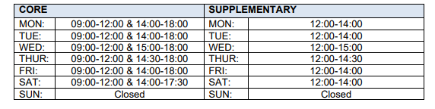

***Prepared by Sarah Weld, Director of Public Health, South Gloucestershire Council. January 2023.***